**APP BASED SOLUTION TO IDENTIFY & SOLVE DISEASE IN PLANTS/CROPS**

### A SEPM Project Report

Submitted To

### Chhattisgarh Swami Vivekanand Technical University Bhilai, India

For

The Partial Fulfillment of Degree of

**Bachelor of Technology**

*in*

**Computer Science & Engineering**

*By*

|  |  |  |
| --- | --- | --- |
| **NIKITA VERMA Roll No.-303302219127**  **En. No.- BH4386**  **Semester 6th (CSE)** | **SACHIN SONI**  **Roll No:303302219084 En. No.- BH3767**  **Semester 6th (CSE)** | **SOURABH SONI Roll No.- 303302219104**  **En. No.- BH3787**  **Semester 6th (CSE)** |

Under the Guidance of

### Mr. Manoj Kumar Singh

Assistant Professor Department of Computer Science &

EngineeringS.S.I.P.M.T, Raipur

**Department of Computer Science & Engineering Shri Shankaracharya Institute of Professional Management & Technology Raipur (C.G.)**

**SESSION 2021-22**

APP BASED SOLUTION TO IDENTIFY & SOLVE DISEASE IN PLANTS/CROPS

**Department of Computer Science & Engineering**

**Shri Shankaracharya Institute of Professional Management & Technology Raipur (C.G.)**

**DECLARATION BY THE CANDIDATE**

We the undersigned solemnly declare that the report of the SEPM Project work entitled App Based Solution to identify & solve disease In Plants/Crops, is based on our own work carried out during the course of our study under the supervision of ***Mr. Manoj Kumar Singh*.**

We assert that the statements made, and conclusions drawn are an outcome of the project work. We further declare that to the best of my knowledge and belief that the report does not contain any part of any work which has been submitted for the award of any other degree/diploma/certificate in this University/deemed University of India or any other country.

|  |  |  |
| --- | --- | --- |
| **Name: Nikita Verma** Roll No.: 303302219127 En. No.: BH4386  Semester: 6th | **Name: Sachin Soni** Roll No.: 303302219084 En. No.: BH3767  Semester: 6th | **Name: Sourabh Soni** Roll No.: 303302219104 En. No.: BH3787  Semester: 6th |

**Department of Computer Science & Engineering**

**Shri Shankaracharya Institute of Professional Management & Technology Raipur (C.G.)**

i

**CERTIFICATE OF THE SUPERVISOR**

This is to certify that the SEPM project report of entitled App Based Solution to identify & solve disease In Plants/Crops is a record of bonafide research work/Project work carried out by **Sourabh Soni bearing Roll No.: 303302219104 & Enrollment No.: BH3787 , Nikita Verma bearing Roll No.: 303302219127 & Enrollment No.: BH4386, Sachin Soni bearing Roll No.: 303302219084 & Enrollment No.: BH3767** under my guidance and supervision for the award of Degree of Bachelor of Technology of Chhattisgarh Swami Vivekanand Technical University, Bhilai (C.G.), India.

To the best of my knowledge and belief the thesis embodies the work of the candidate him/herself, has duly been completed, fulfils the requirement of the Ordinance relating to the B.Tech degree of the University. Is up to the desired standard both in respect of contents and language for being referred to the examiners.

(Signature of HOD) (Signature of Supervisor) Dr. J.P. Patra Mr. Manoj Kumar Rathore

H.O.D, C.S.E Department Asst. Professor, C.S.E Department S.S.I.P.M.T, Raipur (C.G.) S.S.I.P.M.T, Raipur (C.G.)

**Forwarded to**

**Chhattisgarh Swami Vivekanand Technical University, Bhilai**

(Signature of the Principal) **Dr. Alok Kumar Jain** S.S.I.P.M.T, Raipur (C.G)

**Department of Computer Science & Engineering**

**Shri Shankaracharya Institute of Professional Management & Technology Raipur (C.G.)**

ii

**CERTIFICATE BY THE EXAMINERS**

The Thesis/Project entitled App Based Solution to identify & solve disease In Plants/Crops Submitted by **Sourabh Soni Roll No.: 303302219104 & Enrollment No.: BH3787 , Nikita Verma bearing Roll No.: 303302219127 & Enrollment No.: BH4386 , Sachin Soni bearing Roll No.: 303302219084 & Enrollment No.: BH6737** has been examined by the undersigned as a part of the examination and is hereby recommended for the partial fulfillment of the degree of Bachelor of Technology of Chhattisgarh Swami Vivekanand Technical University, Bhilai.

**Internal Examiner External Examiner**

**Date: Date:**

iii

**Department of Computer Science & Engineering**

**Shri Shankaracharya Institute of Professional Management & Technology Raipur (C.G.)**

**ACKNOWLEDGEMENT**

We would like to express our special thanks of gratitude to **Mr. Nishant Tripathi, Chairman of our college** and **Principal Dr. Alok Jain** for encouraging us for this project and providing support and a good infrastructure.

Untitled.pngWe also express our heartfelt gratitude to our **Project Supervisor, Mr. Manoj Kumar Singh, CSE Department** and our **Project Coordinator, Mr. Anand Tamrakar, CSE Department** who gave us this wonderful opportunity to do this project on “App Based Solution to identify & solve disease In Plants/Crops”. It gave us a chance to explore more about augmented reality and the current technology.

We would like to extend our gratitude to **Head of Computer Science and Engineering Department, Dr. J.P. Patra** for rendering all possible help and support during the development, implementation and presentation of the project.



|  |  |  |
| --- | --- | --- |
| **Name: Nikita Verma**  Roll No.: 303302219127 En. No.: BH4386  Semester: 6th | **Name: Sachin Soni**  Roll No.: 303302219084 En. No.: BH6737  Semester: 6th | **Name: Sourabh Soni** Roll No.: 303302219104 En. No.: BH3787  Semester: 6th |

iv

### List of Symbols

|  |  |
| --- | --- |
| **Token** | **Name** |
| ( ) | Parentheses |
| [ ] | Square brackets |
| , | Comma |
| " ", ' ' | Inverted Commas |
| : | Colon |
| - | Hyphen |
| / | Slash |

v

### List of Abbreviations

|  |  |
| --- | --- |
| AI | Artificial Intelligence |
| ML | Machine learning |
| IT | Information Technology |
| SRS | Software Requirements Specification |
| SDLC | Software Development Life Cycle |
| DFD | Data Flow Diagram |

vi

### List of Figures

|  |  |  |
| --- | --- | --- |
| **Figure no.** | **Diagram** | **Page no.** |
| Figure 2.1 | Handheld Display | 04 |
| Figure 3.1 | Incremental Model | 12 |
| Figure 3.2 | Incremental Process Model | 13 |
| Figure 3.3 | DFD 0 | 14 |
| Figure 3.4 | DFD 1 | 15 |
| Figure 3.5 | DFD 2 | 16 |
| Figure 3.6 | Workflow Diagram | 17 |
| Figure 3.7 | Use Case Diagram | 18 |
| Figure 3.8 | Sequence Diagram | 19 |
| Figure 3.9 | Activity Diagram | 20 |
| Figure 3.10 | Collaboration Diagram | 21 |
| Figure 3.11 | Class Diagram | 22 |
| Figure 4.1 | Snapshot | 23 |
| Figure 4.2 | Snapshot | 24 |
| Figure 4.3 | Snapshot | 25 |
| Figure 4.4 | Snapshot | 26 |

vii

### Table of Contents

|  |  |  |
| --- | --- | --- |
| **Chapters** | **Topic** | **Page no.** |
| Chapter I | 1. Introduction about Project    1. Introduction       1. Technologies for AR       2. AR in Education | 01 - 02 |
| Chapter II | 1. Literature Review & Problem Identification    1. Literature Review    2. Problem Identification | 03 - 04 |
| Chapter III | 1. System analysis: Requirement analysis, SRS    1. System analysis       1. Requirement Analysis       2. System Development       3. Unity Software       4. SRS       5. Overall Description       6. User class and characteristics       7. Operating Environment | 05 - 11 |
| 3.2 Type of SDLC Model | 12 – 13 |
| * 1. Data Flow Diagram      1. DFD 0      2. DFD 1      3. DFD 2 | 14 – 16 |
| 3.4 Workflow Diagram | 17 |
| 3.5 Use Case Diagram | 18 |
| 3.6 Sequence Diagram | 19 |
| 3.7 Activity Diagram | 20 |
| 3.8 Collaboration Diagram | 21 |
|  | 3.9 Class Diagram | 22 |
| Chapter IV | 4. Snapshots | 23 – 26 |
| Chapter V | 5. Conclusion | 27 |
| Chapter VI | 6. Future Scope | 28 |
|  | Reference | 29 |

viii

# Chapter – I

## Introduction about Project

xii

### Introduction

India is a cultivated country and about 70% of the population depends on agriculture. Farmers have a large range of diversity for selecting suitable crops and finding suitable pesticides for plants. Disease in crops leads to a

significant reduction in both the quality and quantity of agricultural products. The studies of crop disease refer to the studies of visually observable plant patterns. Monitoring of health and disease on plants plays an important role in the successful cultivation of crops on the farm

In the early days, the monitoring and analysis of crop diseases were done

manually by an expert in that field. This requires a tremendous amount of work and also requires excessive processing time. The image processing techniques can be used in crop disease detection. As we know for a very long time farmers are facing problems in identifying diseases with their naked eyes as they look the same and almost similar. To prevent this situation we need better and perfect guidance on which fertilizers to use, to correctly identify diseases, and to distinguish between two or more similar types of diseases in visuals.

The app could prove to be a game changer in the field, providing farmers with a free, reliable, and quick diagnosis of crop damage with the help of AI.

#### Technology of AI

Artificial intelligence (AI) refers to the simulation of human intelligence in machines that are programmed to think like humans and mimic their actions. The term may also be applied to any machine that exhibits traits associated with a human mind such as learning and problem-solving.

The ideal characteristic of artificial intelligence is its ability to rationalize and take actions that have the best chance of achieving a specific goal. A subset of artificial intelligence is machine learning (ML), which refers to the concept that computer programs can automatically learn from and adapt to new data without being assisted by humans. Deep learning techniques enable this automatic learning through the absorption of huge amounts of unstructured data such as text, images, or video.

xii

#### ML in Image Recognition

Image recognition, a subset of computer vision, is the art of recognizing and interpreting photographs to identify objects, places, people, or things observable in one’s natural surroundings. Finally, the major goal is to view the objects in the same way that a human brain would. Image recognition seeks to detect and evaluate all of these things, and then draw conclusions based on that analysis.

Computer vision, on the other hand, is a broader phrase that encompasses the ways of acquiring, analyzing, and processing data from the actual world to machines. Image recognition examines each pixel in an image to extract relevant information in the same way that humans do. ML cams can detect and recognize a wide range of objects that have been trained in computer vision.

Humans recognize images by utilizing a natural neural network that assists them in identifying items in images gained from previous experiences. Furthermore, the artificial neural network aids robots in image recognition.

Multiple layers of cells in an ML neural network can influence each other. And the complexity of a neural network’s structure and design is determined by the sort of information needed. Image recognition is harder than you might believe because it requires deep learning, neural networks, and advanced image recognition algorithms to be conceivable for machines.

xii

# Chapter-II

## Literature Review & Problem Identification

xii

### Literature Review

In past years, many researchers conduct research on tomato and cotton leaves disease classification by using artificial intelligence based machine or deep learning methods. At present, the research of plant disease recognition in the complex environment mainly focuses on three aspects: disease leaves image segmentation, feature extraction, and disease identification [1].

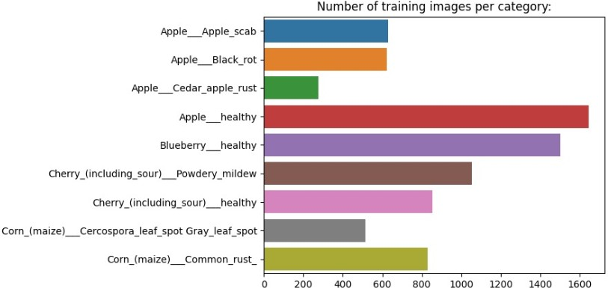

**Figure -** 2.1 Amount of data in plant image

#### Image Segmentation

In the complex environment, the most crucial task is how to segment the images while localizing and detecting diseased plant leaves, since the major aim of image segmentation is to set the symptom information apart from the background. There are many researchers making a deep investigation on it. In 2017, Ali et al. applied the Delta E color difference algorithm to separate the disease-infected area. Some researchers integrate the region of interest (ROI) [2] and other methods to segment images.

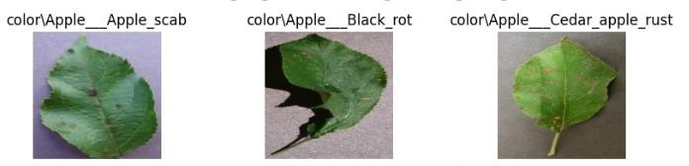

**Figure** - 2.2 Image sample used.

xii

#### Feature Extraction

The feature extraction of plant disease faces many problems in identifying plant disease. The distinct image features include textures, shape, color, and motion-related attributes, which are the essential conditions for disease feature extraction.

#### Disease Identification

As for the precise identification, so many techniques are developed and researched to get accurate results. The identification model focused on using class labels for training images and built a fine-grained image classification system [31]. Zhang et al. reported a recognition method for plant disease leaf images based on a hybrid clustering.

#### Problem Identification

Since the past days and in the present too, farmers usually detect the crop diseases with their naked eyes which makes them take tough decisions on which fertilizer's to use. Some of the diseases look almost similar to farmers often leaves them confused. That’s why we decided to work on this project and help them and to use AI to trained model to identify and provide the plant one with a better solution than blind guessing or relying on basic experience.

xii

# Chapter-III

System analysis: Requirement analysis, SRS

xii

### System Analysis

* + 1. **Requirement Analysis**

In the early days, the monitoring and analysis of crop diseases were done manually by an expert in that field. This requires a tremendous amount of work and also requires excessive processing time. The image processing techniques can be used in crop disease detection.

As we know for a very long time farmers are facing problems in identifying diseases with their naked eyes as they look the same and almost similar. To prevent this situation we need better and perfect guidance on which fertilizers to use, to correctly identify diseases, and to distinguish between two or more similar types of diseases in visuals

### The Trigate Audience

Target audience are farmers who are not able to detect diseases due to lack of resources, also shop retailers and plant parents additionally it can be used by other people who want to detect diseases in their crops

### Project Scope

The purpose of this app is to provide farmers with a free, reliable, and quick diagnosis of crop damage with the help of AI.

The diseases are responsible for direct monetary loss and material loss. Plant diseases still inflict suffering on untold millions of people worldwide causing an estimated annual yield loss of 14% globally with an estimated economic loss of 220 billion U.

S. dollars. The application is developed in two stages.

India population is expected to reach more than 1.6 billion by 2030. With this huge hike in population, one can expect massive demand for agricultural consumption as well. With the advancement in the service sector, there is a big migration of workforce from the primary sector to the tertiary sector. In addition, the ignorance of rising diseases in crops is decreasing the yield of cultivation as well. Food being the primary necessity of human life, future researches need to take direction for reviving the agriculture arena. Artificial Intelligence should be the major tools for the researchers to address the above-mentioned issues. By using proper tools of artificial intelligence and with the proper dataset, farming can be made more efficient for farmers. These methods can be considered as the major implementations to solve the future crisis.

### System Development

#### Plant decides Data set

Images of various crops are labelled with the desires names identified by plant experts to provide a good data set to model to be trained on

#### Planning and Developing the System

This study was conducted in two stages. In the first stage, the AI system and teaching materials were developed and during the second stage, deployment of the AI system and teaching material is done. Software such as React Native and android were used.

#### Developing the AI Models

During the training phase

#### Tensor-Flow

TensorFlow offers multiple levels of abstraction so you can choose the right one for your needs. Build and train models by using the high-level Keras API, which makes getting started with TensorFlow and machine learning easy.

If you need more flexibility, eager execution allows for immediate iteration and intuitive debugging. For large ML training tasks, use the Distribution Strategy API for distributed training on different hardware configurations without changing the model definition.

In order to help users cut down on the amount of time needed for game design as well as the complexity and expense of our efforts, Unity offers a wealth of documentation, projects, and tutorials.

#### A. Training a neural network

Neural networks are trained by gradient descent. The weights in each layer begin with random values, and these are iteratively improved over time to make the network more accurate. A loss function is used to quantify how inaccurate the network is, and a procedure called backpropagation is used to determine whether each weight should be increased, or decreased, to reduce the loss.

### SRS

#### Safety Requirements

The recovery method restores a previous copy of the database that was backed up to archival storage (typically tape) and reconstructs a more current state by reapplying or redoing the operations of committed transactions from the backed up log, up to the time of failure if there is extensive damage to a wide portion of the database.

#### Security Requirements

Like many other applications, security systems require database storage. Vendors must, however, make a careful choice in terms of their database partner due to the unique requirements of the security sector.

#### Overall Description

An app based solution to identify and solve diseases in plants/crops. information:

* Camera module :

the mobile camera module to take image of the crop.

* Plant Diseases Discerption :

A info tab describing all the solution and information related to the crop and the diseases.

#### User Class and Characteristics

OPERATING ENVIRONMENT

Operating environment for the augmented reality in education system is as listed below:

* Operating system: Android 7.0 / iOS 9 or above
* Vuforia 10.7 or above
* Android min SDK version

#### Most Important and Basic feature

taking picture of plant/ crop deices and able to identify decide and find cure of it . Overview of Functional requirements (Modules)-

#### Start Camera

By opening the application, user first get access to camera. The camera in work is back camera for taking input image or user can use image picker.

#### Detect Image

The camera will point towards the plant/crop and detect it’s diseases .

#### Collect image Information

After detecting the plant/crop ,our AI trained algorithm try to figure out type of diseases and all the related information should be loaded.

#### Gather information

When the plant is getting detected, the mobile will s

#### Image Acquisition

Images of the infected leaves are obtained. This database has different types of plant diseases, and the images are stored in JPEG format.

#### Image Pre-processing

Image pre-processing is used to erase noise from the image or other object exclusion, different pre-processing techniques. Image scaling is used to convert the original image into thumbnails because the pixel size of the original image is large and it requires more time for the overall procedure hence after converting the image into thumbnails the pixel size will get decreases and it will require less time.

#### Image segmentation

Image segmentation is one of the most widely used methods to distinguish pixels of image well in a targeted app. It distributes an image into numerous discrete states such that the pixels have great similarity in each area and high dissimilarity between areas.

#### Feature Extraction

Feature Extraction is an important part of disease detection. It plays an important role in the identification of an object. Feature extraction is utilized in several applications in image processing. Colour, texture edges, morphology are the features, which are utilized in disease detection.

#### Detection and classification of plant diseases

The final stages are the detection of the diseases and with the help of disease classify the plants with the disease matches with the given dataset.

#### Check DB for cure

after all image processing is done and information is collected about the deices the app will look for cure in our curated database

#### Camera Toggle

The user can switch between front and back camara, and can read more abut the information on plant deices or can find cure .

### Type of SDLC Model

Incremental Model

The incremental process model is also known as the Successive version model.

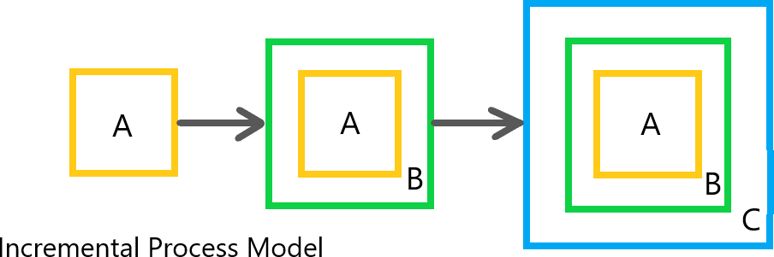

**Figure 3.1 Incremental Process Model**

Figure 3.1 shows a simple working system implementing only a few basic features and then that is delivered to the customer. Then thereafter many successive iterations/ versions are implemented and delivered to the customer until the desired system is released. Incremental Model is a process of software development where requirements divided into multiple modules of the software development cycle as shown in figure 3.2. In this model, each module goes through the requirements, design, implementation and testing phases.

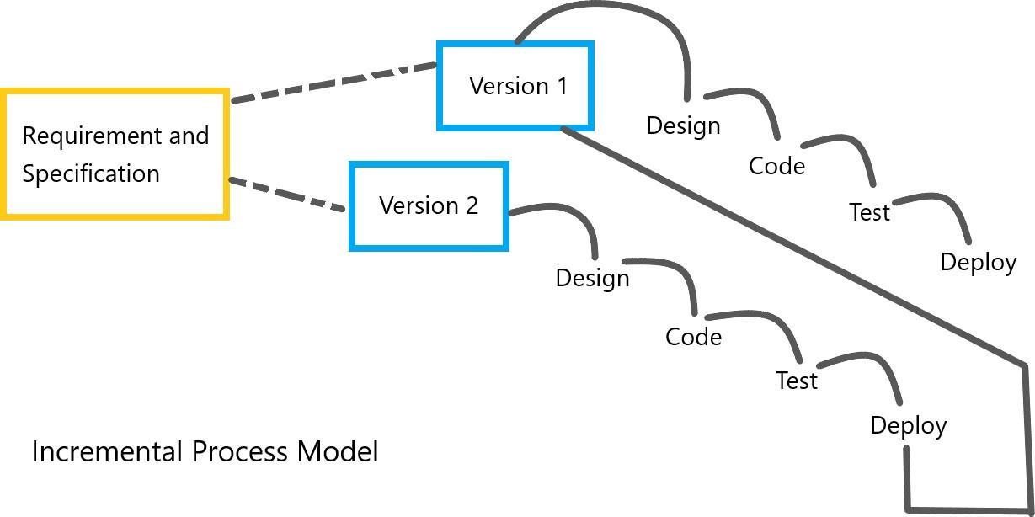

**Figure 3.2 Incremental Process Mode**

### Data Flow Diagram

A Data Flow Diagram or (DFD) is a way of visual representation of a flow of data in a certain process or system. The data flow diagram can provide information about the process, inputs, and outputs of each entity.

### DFD 0

Context DFD is the entrance of a data flow model. It contains one and only one process and does not show any data store. This diagram is also known as context diagram. As in the figure 3.3, context diagram is supposed to be an abstract view, with the mechanism represented as a single process. This DFD for the system depicts the overall structure as a single bubble. It comes with incoming/outgoing indicators showing input and output data.

|  |
| --- |
|  |

**Figure 3.3 DFD 0**

### DFD 1

Next to the context diagram is the level 1 data flow diagram. The content AI Model is further divided into 3 sub processes shown in figure 3.4. In this level, the system must display or reveal further processing information.

With being knowledgeable about DFD level 1, user will know its broaden context terms. In addition to that, this may also serve as user reference on how the inputs or data fed on the system. Then user will also be informed about the outputs that the system gives.

|  |
| --- |
|  |

**Figure 3.4 DFD 1**

### DFD 2

2-level DFD goes one step deeper into parts of 1-level DFD. The Level 2 DFD for the artificial intelligence Model should represent the basic modules as well as data flow between them as shown in figure 3.5. The DFD level 2 is the highest abstraction level and it can be usedto plan or record the specific/ necessary detail about the system’s functioning. The presented level gives user precise destination of the data that flows in the system along with showing user the detailed processes of system. In this the Target management system is used.

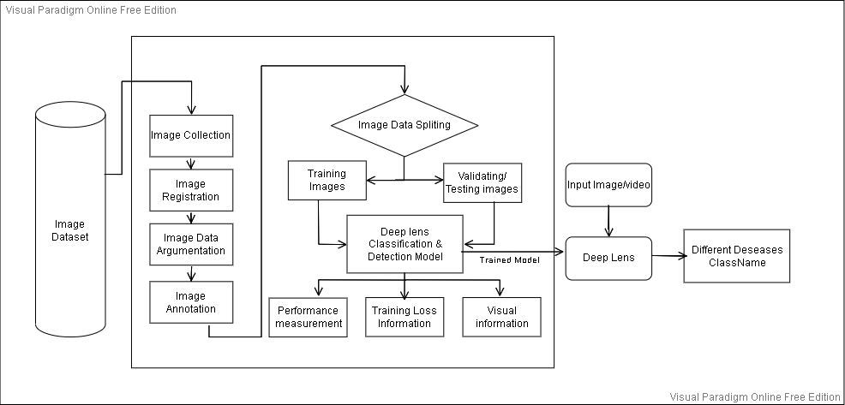

**Figure 3.5 DFD 2**

### Workflow Diagram

|  |
| --- |
|  |

**Figure 3.6 Work Flow Diagram**

### Use Case Diagram

Use-case diagrams give a system's high-level operations and domain. These diagrams show how the system's actors interact with the system. Use-case diagrams' use cases and actors describe what the system does and how the actors use it, but they not describe how the system functions internally.

The plant owner and plant expert are portrayed in figure 3.7 as actors interacting with AI app options such as the camera access option to take picture of plant, the search details option to view the corresponding detail about plant/crop, and the Result option to view the result and cure on separate page.

|  |
| --- |
|  |

**Figure 3.7 Use Case Diagram**

### Sequence diagram

A sequence diagram depicts the flow of messages between objects during an interaction. A series of objects are represented by lifelines in a sequence diagram, together with the messages they exchange during the course of an interaction.

The communication path between items is depicted in a sequence diagram. There are three main objects in figure 3.8: the user, the image Collector , the Paired dataset Creation, the H function, and the DF function . Various communication sequences are set up between these objects to show the flow of messages between them. Here, three main communication chains are shown, primarily for the three options of displaying the result from the AI model, create the paired dataset run SVM classifier and Model performance and recommendation analysis.

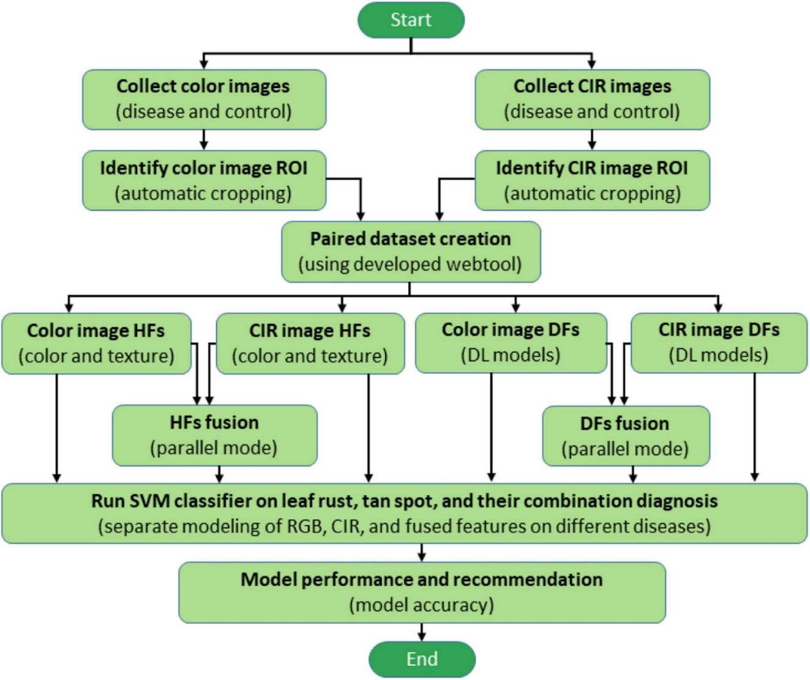

**Figure 3.8 Sequence Diagram**

### Activity diagram

In essence, an activity diagram is a flowchart that illustrates how one activity leads to another. The activity diagram is shown in figure 3.9 along with the circumstances and order in which the activities take place. Here, the process of getting image and passing that image to the AI Model. After that, the AI model collect required data from the data base and generate result and at the end activity closes.

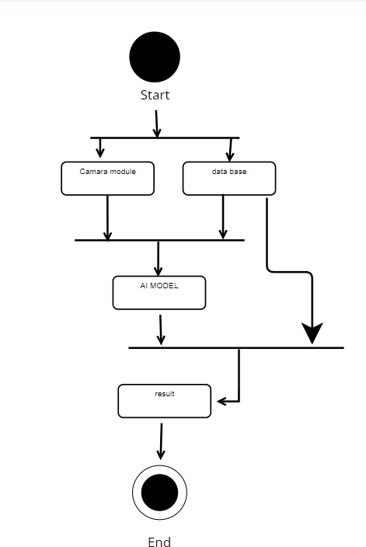

**Figure 3.9 Activity Diagram**

### Collaboration diagram

In the Unified Modeling Language, a collaboration diagram—also called a communication diagram—illustrates the connections and interactions between software elements. The functions of the objects: AI Model, identify Disease , DB, and display Cure are defined in figure 3.10 along with the dynamic behavior of a particular use case for each item. Here, the user are the actors, and the figure shows how the application of artificial intelligence works logically through message flow and relationships between objects that are represented by arrows.

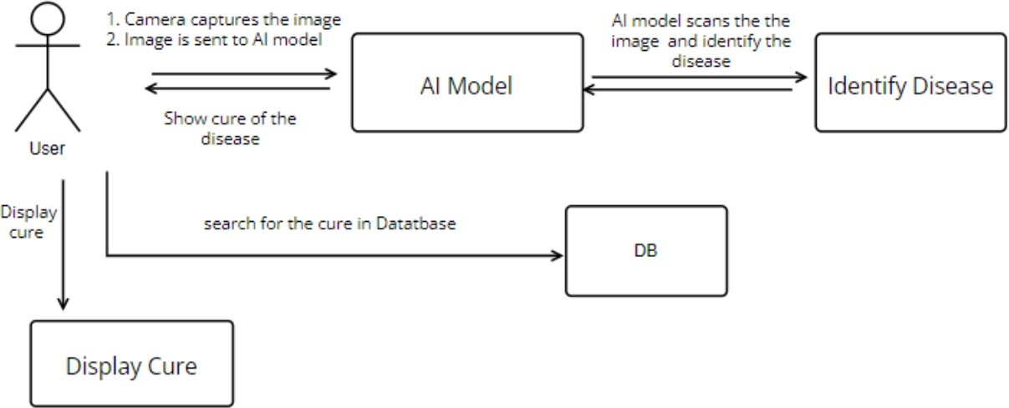

**Figure 3.10 Collaboration Diagram**

### Class diagram

In figure 3.11, following classes are identified:

1. UL Solver
2. System Solver
3. D_Field
4. Edge Detector
5. F_Field
6. G-Filed
7. Image Filed

|  |
| --- |
|  |

**Figure 3.11 Class Diagram**

# Chapter-IV Snapshots

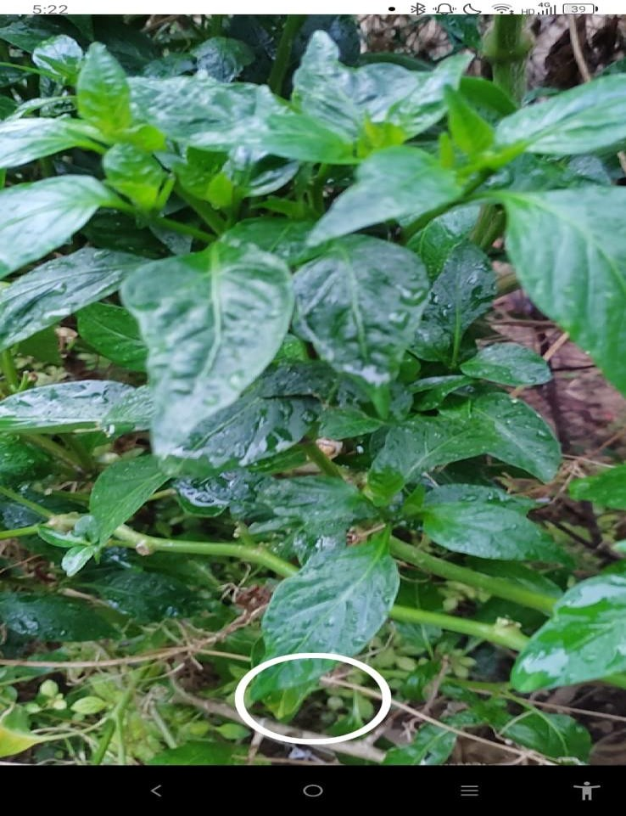

**Figure 4.1**

In figure 4.1 Camera module:

Click photo: The app has a feature that allows the user to take a photo of a plant using their device's camera. Upon clicking the "click photo" button, the photo is captured and sent to the model for identification and information retrieval.

Hold to pick: The app also has a feature that allows the user to select an image from their device's gallery instead of capturing a new one. Upon long-pressing the "click photo" button, an image picker appears, and the user can select a photo of a plant from their device's gallery to send to the model for identification and information retrieval.

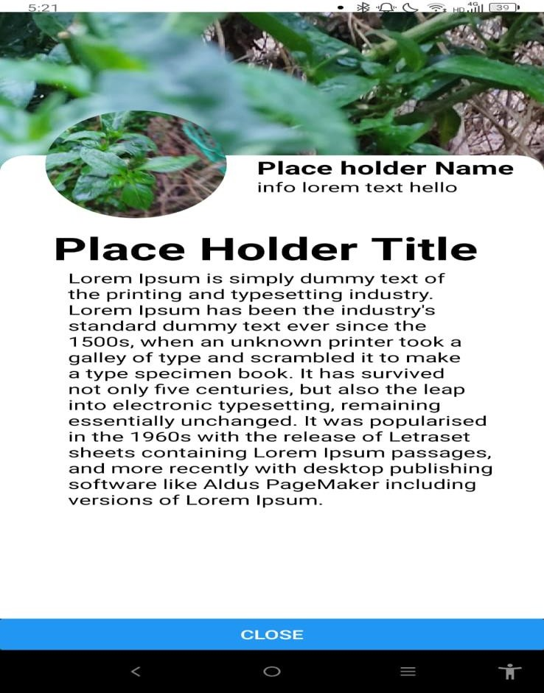

**Figure 4.2**

In figure 4.2 info Model:

An app that can perform image recognition can be used to identify different types of plants and provide information on their care and cultivation. This can be a useful tool for gardeners and plant enthusiasts, allowing them to easily identify and learn about the plants in their collection. An app that can perform image recognition can be used to identify different types of plants and provide information on their care and cultivation. This can be a useful tool for gardeners and plant enthusiasts, allowing them to easily identify and learn about the plants in their collection. he app can also give tips on how to care for the plant, such as how much water and sunlight it needs, and how to address any potential pests or diseases. Additionally, the app can also provide suggestions for similar plants that can be grown in the same conditions and can complement the identified plant

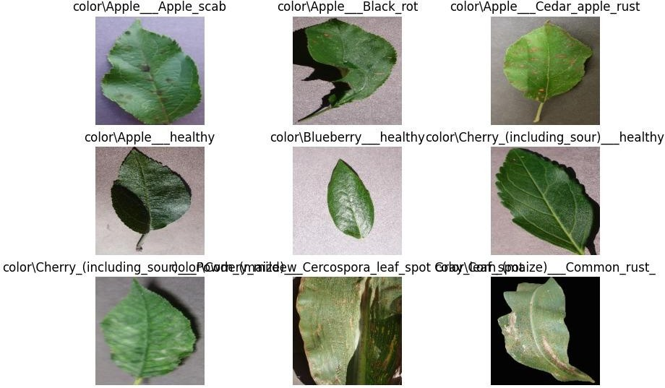

**Figure 4.3**

Backend details

Plant details: The app can store information on a wide variety of plants, including their common and scientific names, characteristics, and ideal growing conditions. This information can be organized and searchable by plant type, such as flowers, vegetables, or herbs.

Leaf details: The app can also include detailed information on the leaves of the plants, such as shape, size, color, and texture. This can be helpful in identifying a plant, as the leaves can often be a key distinguishing characteristic.

Backend: The app can use a database to store and organize all the plant information. The database can be updated regularly to ensure that the information is accurate and up-to-date. Additionally, the app can use machine learning algorithms to improve its image recognition capabilities over time, as it receives more data.

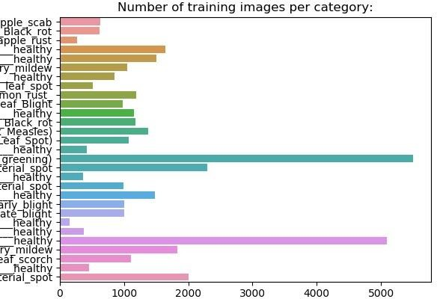

**Figure 4.4**

In figure 4.4:

the algorithm prediction details section of the app shows the user the quantity of images in the database that the app is using to recognize and identify plants. The more images in the database, the more accurate the app's predictions will be.

The app also has a database of plants that is used to provide detailed information on each plant. This database can be updated regularly to ensure that the information is accurate and up-to-date. The user can also be able to access and search the database, making it easy for them to find the information they need about a particular plant. This database of plants is a key component of the app, as it allows the app to provide accurate and detailed information on a wide variety of plants.

## Chapter-V Conclusion

#### 5.1 Conclusion

Plant Diseases are major food threats that should have to overcome before it leads to further loss of the entire field. But, often farmers unable to distinguish between similar symptoms but ace different diseases. This will mislead to wrong or overdosage of fertilizers . Faced with growing demands, shrinking of natural resources, and more stringent regulations, the agriculture sector worldwide found refuge in AI through the use of smart and innovative IoT technologies to optimize production and minimize losses. Without proper identification of the disease, disease control measures can waste money and lead to further plant losses. To increase the system usefulness We developed a mobile app that would create a better opportunity for limited-resources farmers to detect plant diseases in their early stages and eliminate the use of incorrect fertilizers that can hurt the health of both the plants and soil Present review study summarize the different applications of artificial intelligence in agriculture sector. The main motive of this study was to brief the applications and available techniques of artificial intelligence to solve the problems of farmers in getting the required yield. The paper also highlights the different literatures, which reflects various methodologies to detect the diseases in crops. From the literature, it is concluded that artificial intelligence is a great tool for a nation’s agronomics. Hence, future researchers should organize a proper dataset covering all arena of agriculture and enhance the available technologies to increase the productivity of primary sectors.

The accurately detection and classification of the plant disease is very important for the successful cultivation of crop and this can be done using image processing. This paper discussed various techniques to segment the disease part of the plant.

This paper also discussed some Feature extraction and classification techniques to extract the features of infected leaf and the classification of plant diseases. The use of ANN methods for classification of disease in plants such as self organizing feature map, back propagation algorithm, SVMs etc. can be efficiently used. From these methods, we can accurately identify and classify various plant diseases

using image processing techniques.

## Chapter-VI Future Scope

### Future Scope

India population is expected to reach more than 1.6 billion by 2030. With this huge hike in population, one can expect massive demand for agricultural consumption as well. With the advancement in the service sector, there is a big migration of workforce from the primary sector to the tertiary sector.

In addition, the ignorance of rising diseases in crops is decreasing the yield of cultivation as well. Food being the primary necessity of human life, future researches need to take direction for reviving the agriculture arena.

Artificial Intelligence should be the major tools for the researchers to address the above- mentioned issues. With the great diversity in agronomy species, a detailed database needs to be obtained for various portions of agriculture. By using proper tools of artificial intelligence and with the proper dataset, farming can be made more efficient for farmers. These methods can be considered as the major implementations to solve the future crisis. We can easily provide better solutions to the farmers with the help of AI. This will increase the growth of healthy crops and better food to eat which is a basic necessity for everyone’s life.

### REFERENCES

Online Resources:

* + 1. Kaur, S., & Gill, B. S. (2016). Plant disease detection using image processing. Frontiers in plant science, 7, 1419. https://www.frontiersin.org/articles/10.3389/fpls.2016.01419/full
    2. Sample images of plant diseases. (n.d.). ResearchGate. https://www.researchgate.net/figure/Sample-images-plantdiseases_fig1_344137784
    3. Github. (n.d.). https://www.github.com
    4. React Native. (n.d.). https://reactnative.dev/
    5. Sachin, S. (n.d.). PlantE. https://github.com/sachi1402/plante
    6. SOURBH, S. (n.d.). Miner Project. https://github.com/SSOURABH58/MinerProject
    7. N.A (2021). "A deep learning approach for plant disease detection and diagnosis using leaf images" Science Direct. https://www.sciencedirect.com/science/article/pii/S1877050920324613

Books and Articles:

* + 1. Diseases of Crop Plants in India
    2. AN IDENTIFICATION OF CROP DISEASE USING IMAGE SEGMENTATION (http://ijpsr.com/bft-article/an-identification-of-crop-disease-using-image-segmentation/?view=fulltext)
    3. A Deep Learning Approach for Plant Disease Detection and Diagnosis using Leaf Images (https://arxiv.org/ftp/arxiv/papers/2106/2106.10698.pdf)
    4. Mastering OpenCV 4 with Python
    5. Note:
    6. You might have provided me with broken links (https://www.researchgate.net/figure/Sample-images-plantdiseases_fig1_344137784, https://www.github.com)
    7. Please verify the links before you use them.